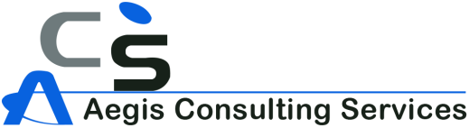   
 **MINUTES OF MEETING**

|  |  |
| --- | --- |
| **DATE** | 01/12/2017 (FRIDAY) |
| **VENUE** | AEGIS Conference Hall |
| **SUBJECT** | New requirements from Client - Commissionerate of Health and Family Welfare, Andhra Pradesh on PNPNDT (MRMS) Demo |

|  |
| --- |
| **Members Participated in the Meeting** |
| 1. Sir.Vamshi (project manager) 2. Shiva Krishna(test engineer) 3. Raju (software engineer) 4. Bharath (Business Analyst) 5. Deepak ( trainee business Analyst) |

|  |
| --- |
| **OUTCOME OF THE MEETING** |
| * Form( d-h) development and integration with our proposed system * Patient data report submission to the Medical Department * Have to develop required forms. * Database input from them. * Send the data to department according to their requirement * Expecting 1) wireframes from (BA)   2)Test cases from (test engineer )  3) Development Estimate (software engineer) for 1. Smart forms, 2. Generic forms and 3. Excel upload |

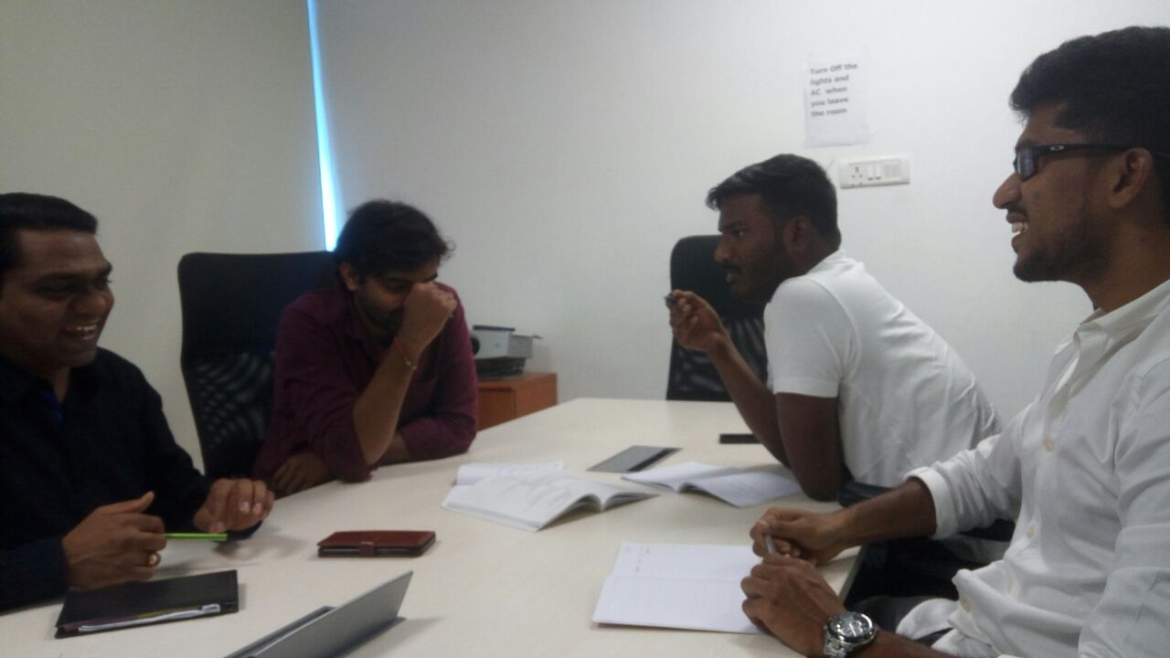

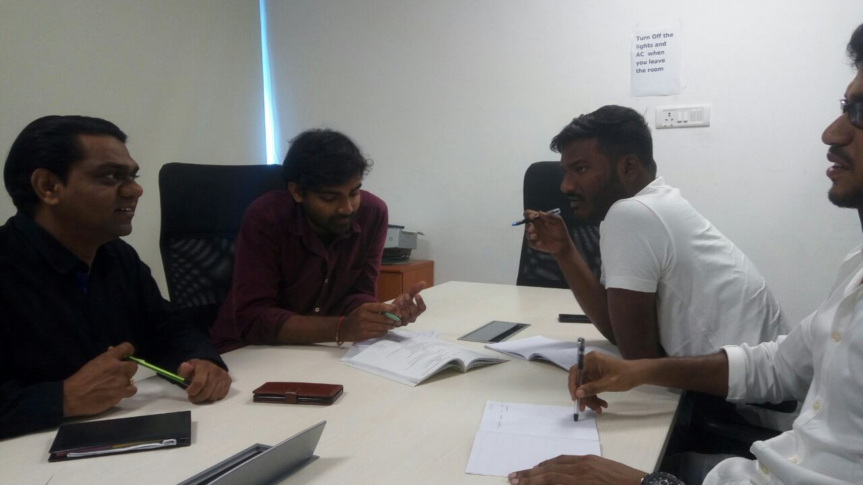

MEETING PHOTOGRAPH (1) MEETING PHOTOGRAPH (2)

Reported By

Deepak Bollampally

Business Analyst